NOTEBOOK SET UP for UNIT 3
- Open to your first BLANK PAGE
- Put the sticker tab given to you on the side of the page so to easily find this section in your notebook. Put a 3 on the tab.
- Write UNIT 3 on this page. This is the page on the right with your notebook open.
UNIT 3

Algebraic Expressions

Table of Contents
p. 3 BR- 3.1 Pre-assessment
p. 4 Vocabulary
p. 5 Identify Like Terms and Simplify Expressions
p. 6 Simplify Expressions Continued and Real Life example
p. 7 Homework 3.1
p. 8 Bell Ringer
p. 9 Homework 3.1 cont.

Monday: Bell Ringer 3.1 Pre-assessment
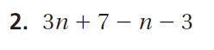
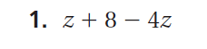

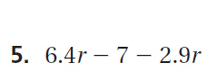

Unit 3 KEY Vocabulary
p.82 Like Terms – are terms that have the same variables
raised to the same exponents. Constant terms are
also like terms.
p.82 Simplest Form – when an algebraic expression has no
like terms and no parentheses.
p.88 Linear Expression – is an algebraic expression in
which the exponent of the variable is 1.
p.92 Factoring an Expression – you write the expression
as a product of factors.

p.98 Equivalent Equations – are two equations that have
the same solutions.

Unit 3 KEY Vocabulary Continued

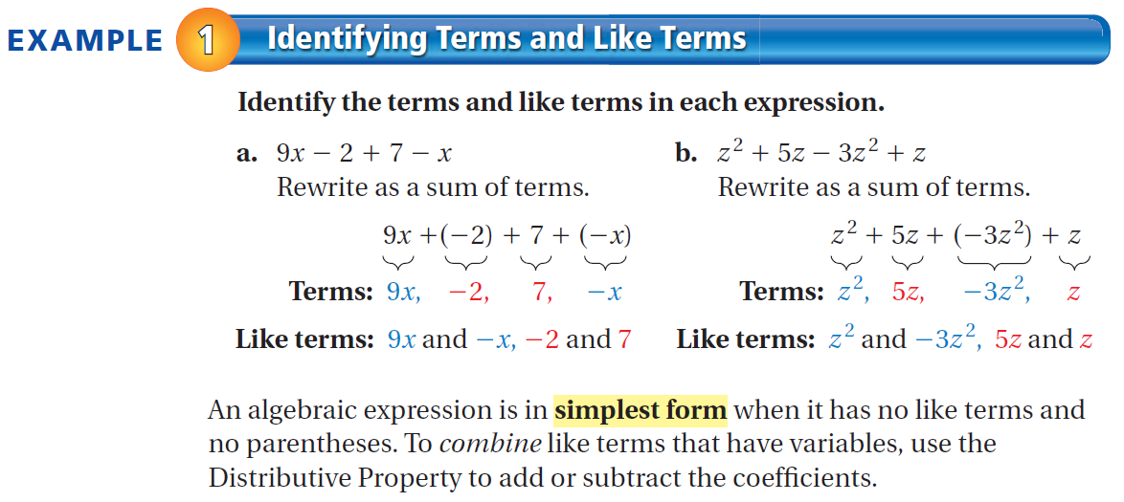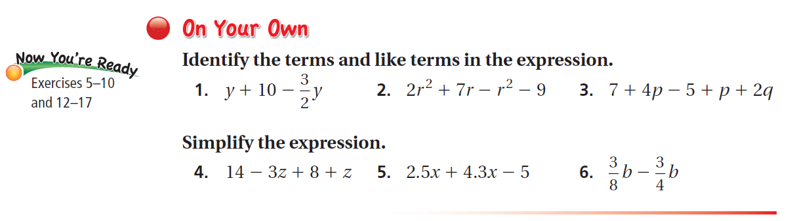
Book p. 82-83

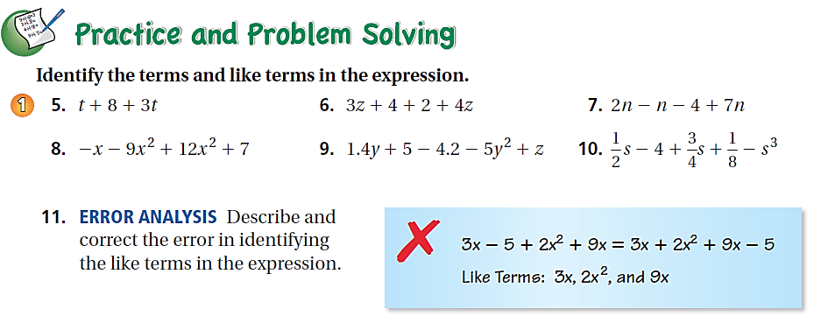
Odd ONLY

Check your homework. Write the number correct on the top of your page.
Bell Ringer 12/1/15
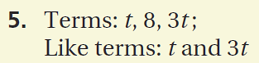
Identify the Terms and Like Terms in each expression below.
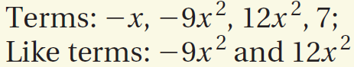
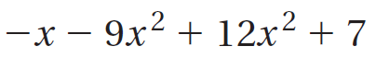
a)
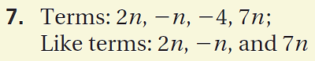
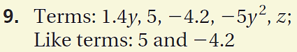
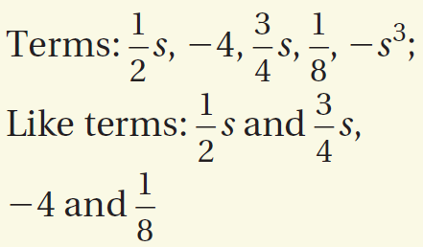
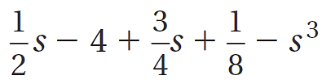
b)
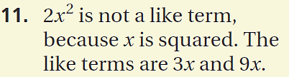

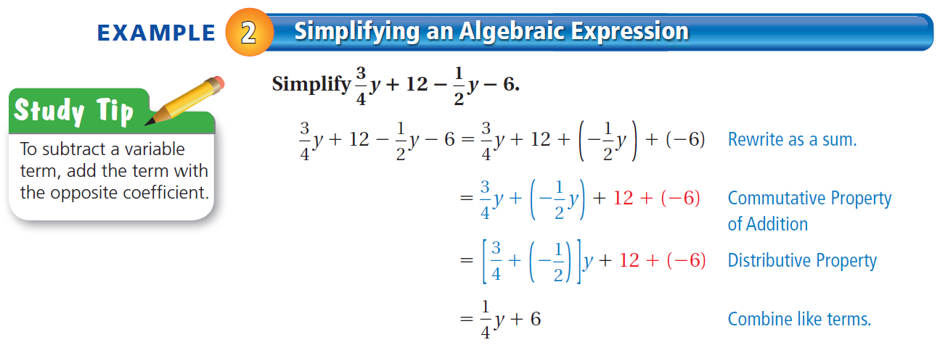
Do ON YOUR OWN 4-6 below example 2 here.
Show all of your work

Homework 12 – 17
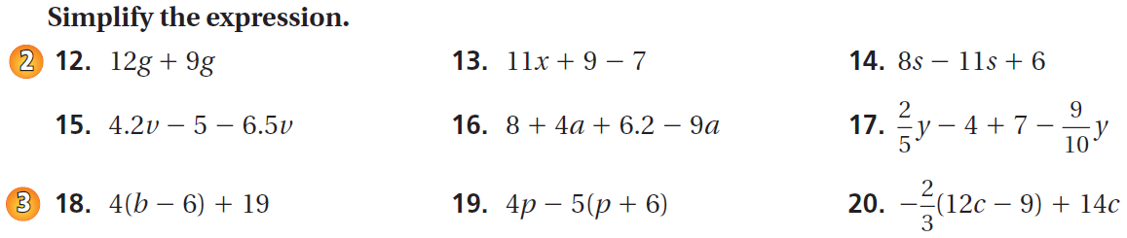

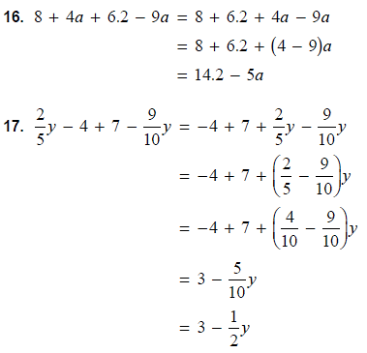
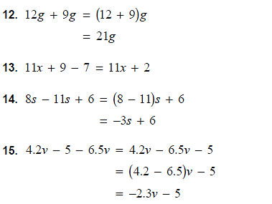

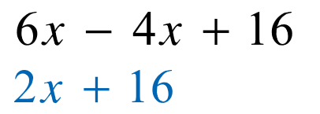
Bell Ringer 12/2/15 - DO ON PAGE 11 of Unit 3 in your notebook
a)
Check your homework. Write the number correct on the top of your paper.
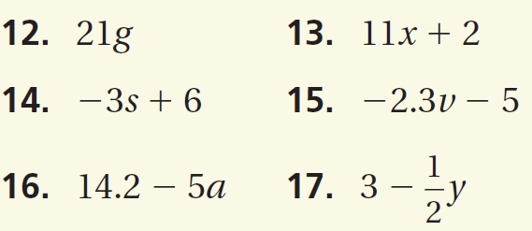
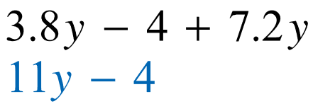
b)

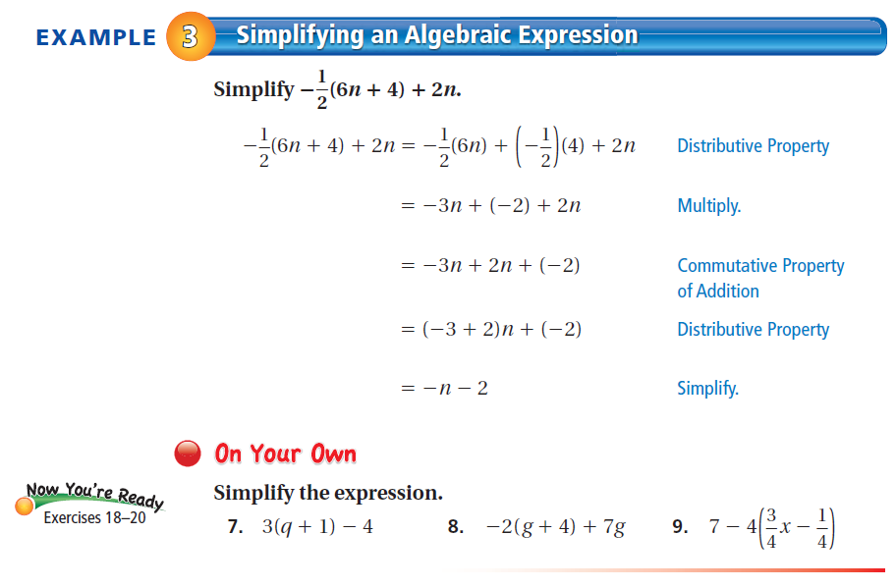
Do ON YOUR OWN 7-9 below example 3 here.
Show all of your work

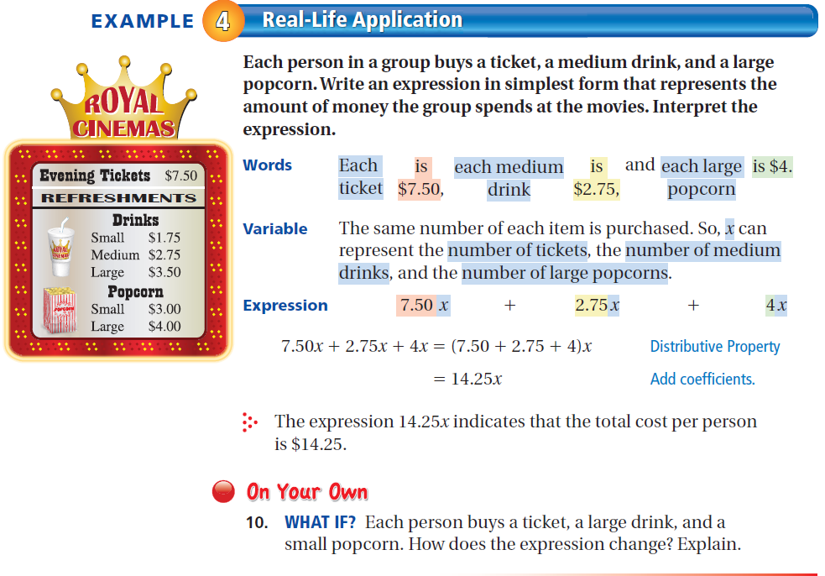

Do ON YOUR OWN 10 below example 4 here.
Show all of your work

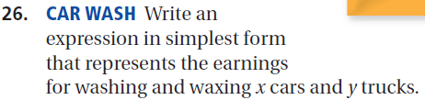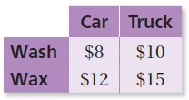

Show your work for the homework problems on this page.
Please keep your work organized and number all problems.
Write your final answer on the Homework sheet.

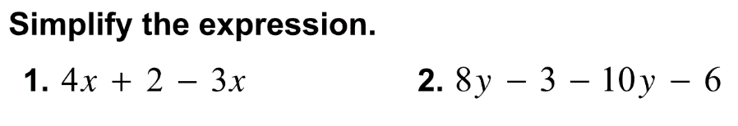
Bell Ringer:

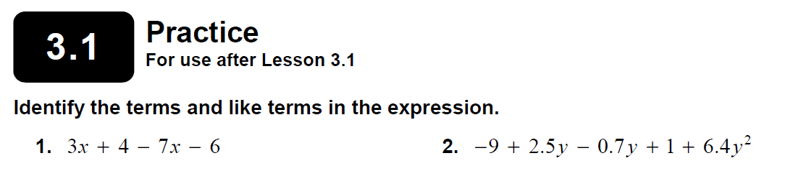

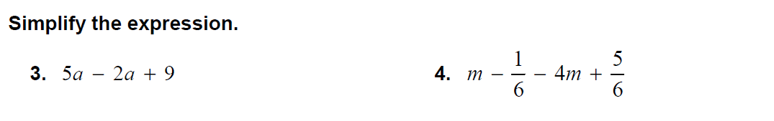

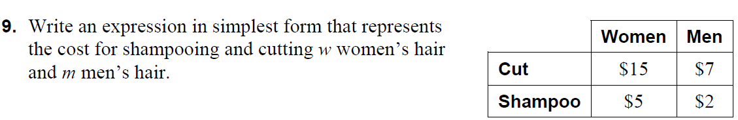

Show your work for Practice 3.1 here
Write your final answer on the practice sheet on the left page.

Wednesday Bell Ringer:
Use the key above to write the sum or difference of two algebraic expressions modeled by the algebra tiles. Then use the algebra tiles to simplify the expression.
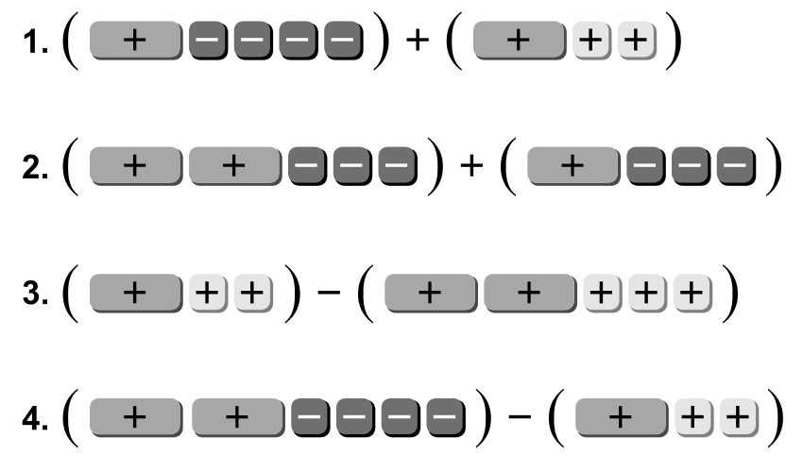

Wednesday Bell Ringer:
Use the key above to write the sum or difference of two algebraic expressions modeled by the algebra tiles. Then use the algebra tiles to simplify the expression.
Bell Ringer notes go here

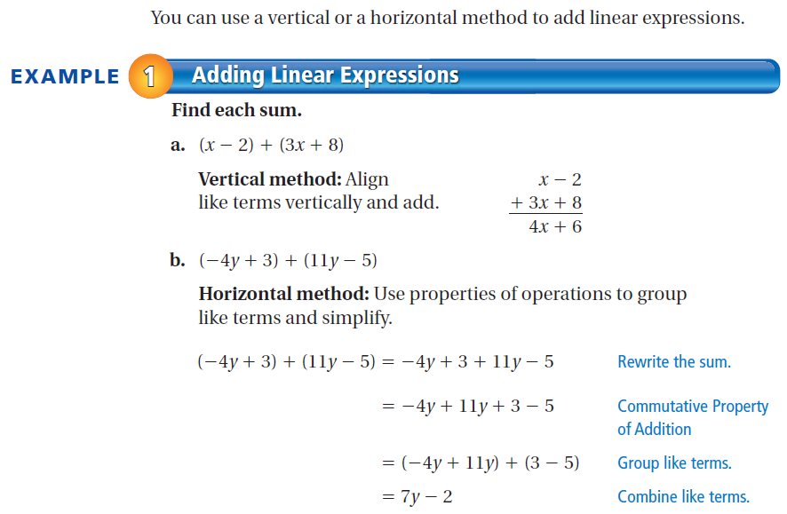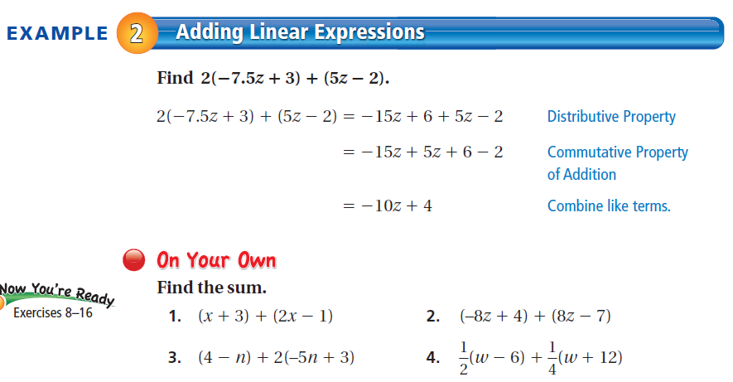

Do ON YOUR OWN 1-4 on this page
Show all of your work!

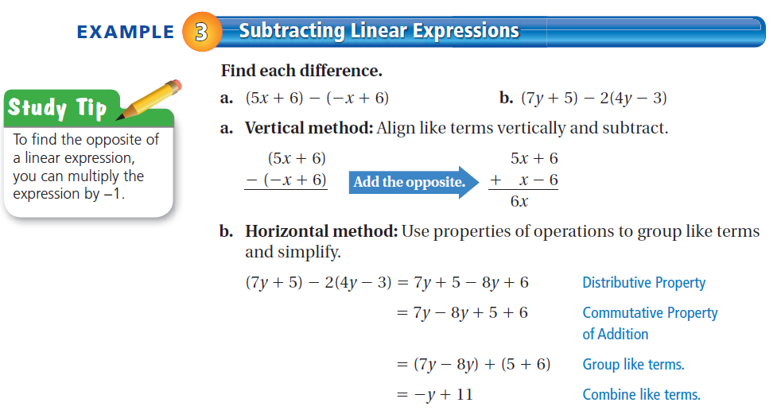
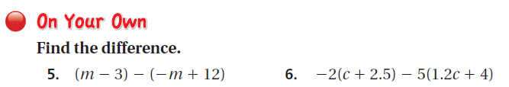
Do ON YOUR OWN 5-6 below example 3 here.
Show all of your work

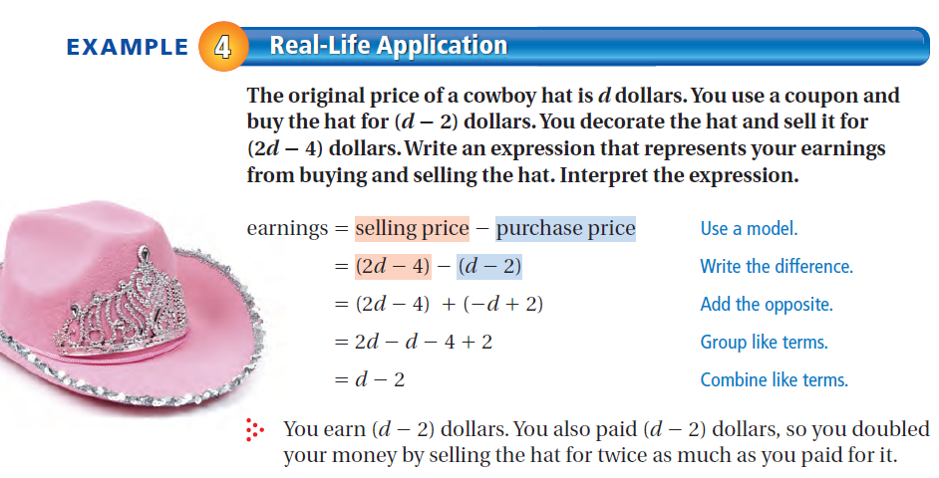
Do ON YOUR OWN 7 below example 4 here.
Show all of your work

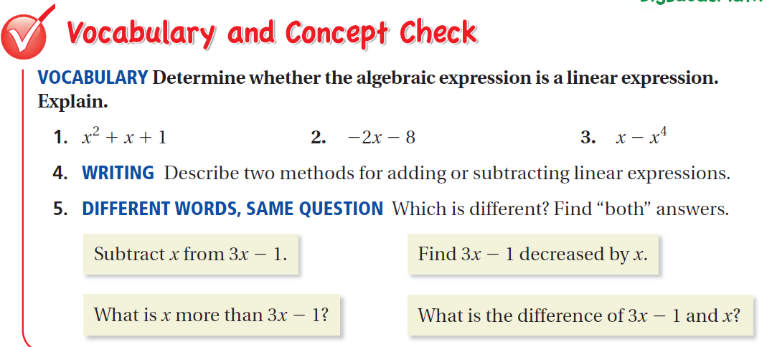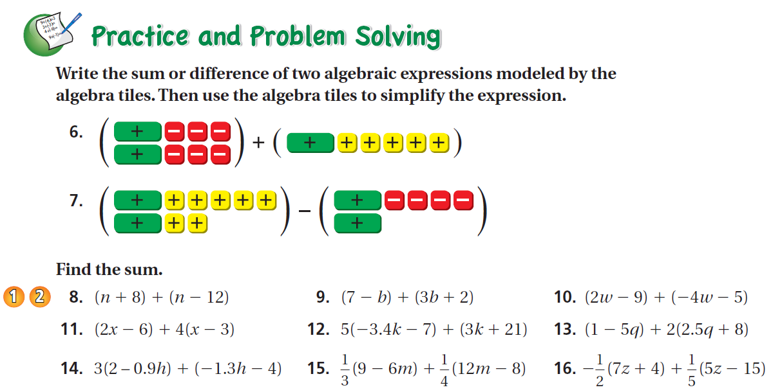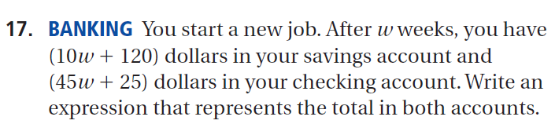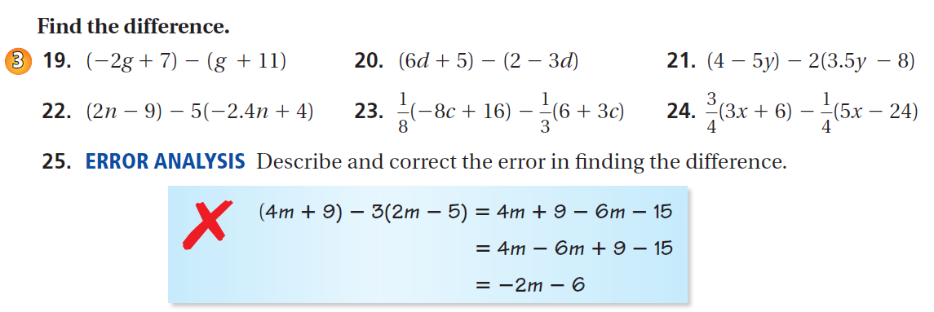
Odd ONLY
Show your work for the homework problems on this page.
Please keep your work organized and number all problems.
Write your final answer on the Homework sheet on the left page.

Bell Ringer Quiz

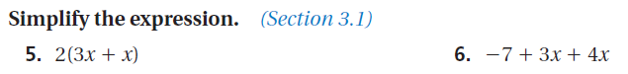

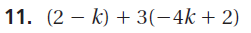
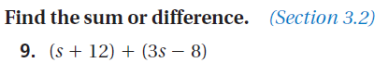

Bell Ringer Quiz

Use to show your work for the Bell Ringer Quiz.

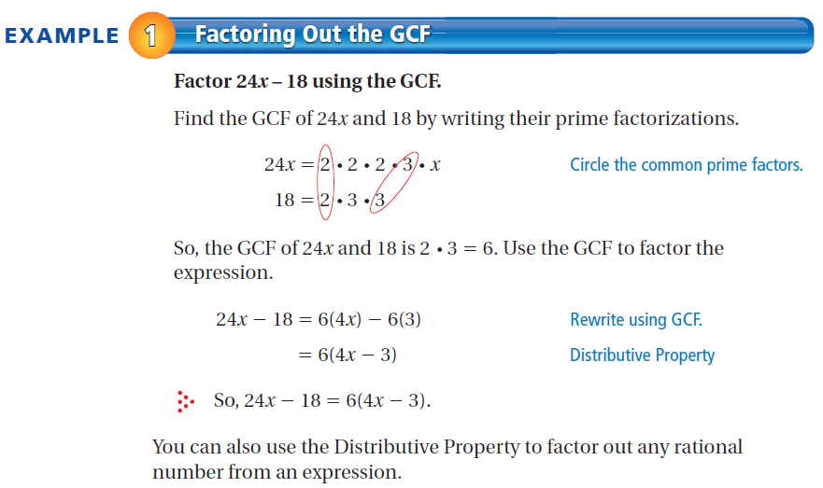
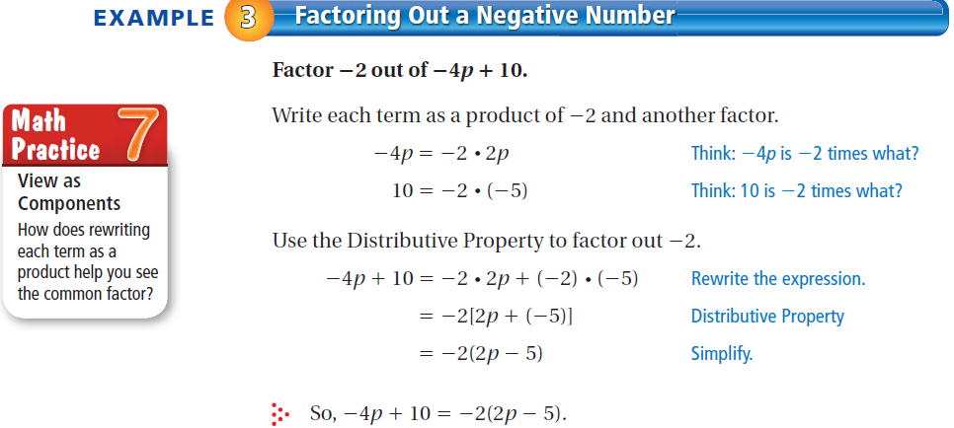

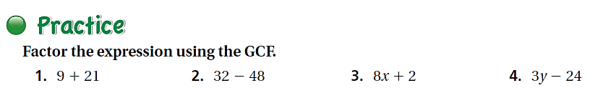

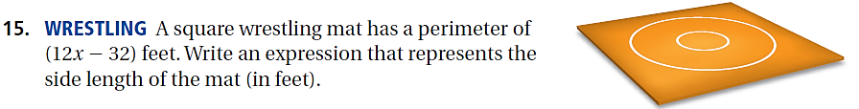
Do ON YOUR OWN 1-4 and 15 below. Show all of your work

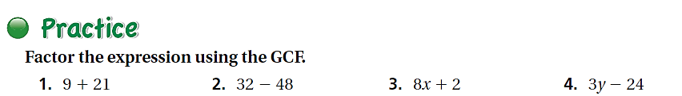

Do ON YOUR OWN 1-4 and 15 below. Show all of your work

3.1 Notes
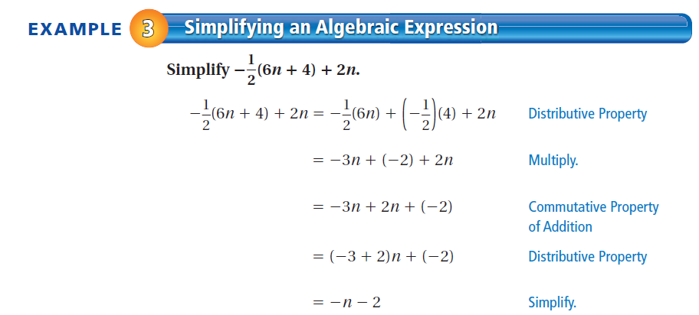

3.2 notes
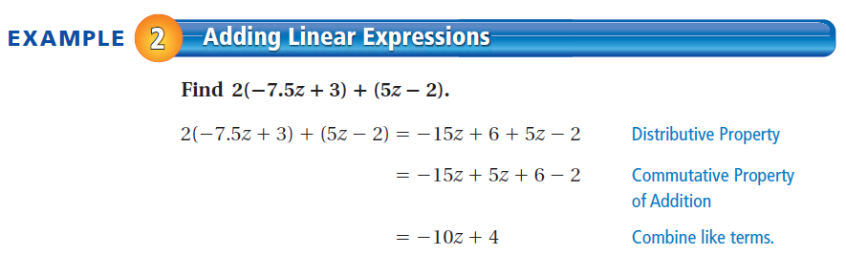

3.2 Ext. Notes

